**TUGAS MULTIPLE JOIN QUERY**

1. **Syntax :**

[SELECT](http://localhost/phpmyadmin/url.php?url=https://dev.mysql.com/doc/refman/8.0/en/select.html" \t "http://localhost/phpmyadmin/index.php?route=/table/mysql_doc) jenis\_obat FROM jenis\_obat INNER JOIN obat ON jenis\_obat.id = obat.jenis\_obat INNER JOIN transaksi ON obat.id = transaksi.id\_barang;

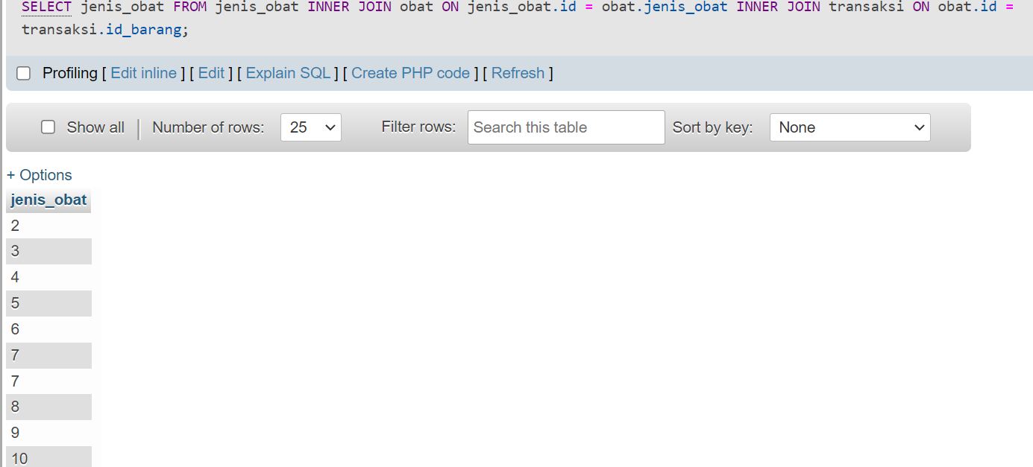’

1. Syntax

[SELECT](http://localhost/phpmyadmin/url.php?url=https://dev.mysql.com/doc/refman/8.0/en/select.html" \t "http://localhost/phpmyadmin/index.php?route=/table/mysql_doc) jenis\_obat.id,jenis\_obat.active,jenis\_obat.nama\_satuan, obat.id,obat.nama\_barang,obat.jenis\_obat,transaksi.id,transaksi.id\_barang

FROM jenis\_obat

INNER JOIN obat ON jenis\_obat.id = obat.jenis\_obat

INNER JOIN transaksi ON obat.id = transaksi.id\_barang

ORDER BY obat.id DESC;

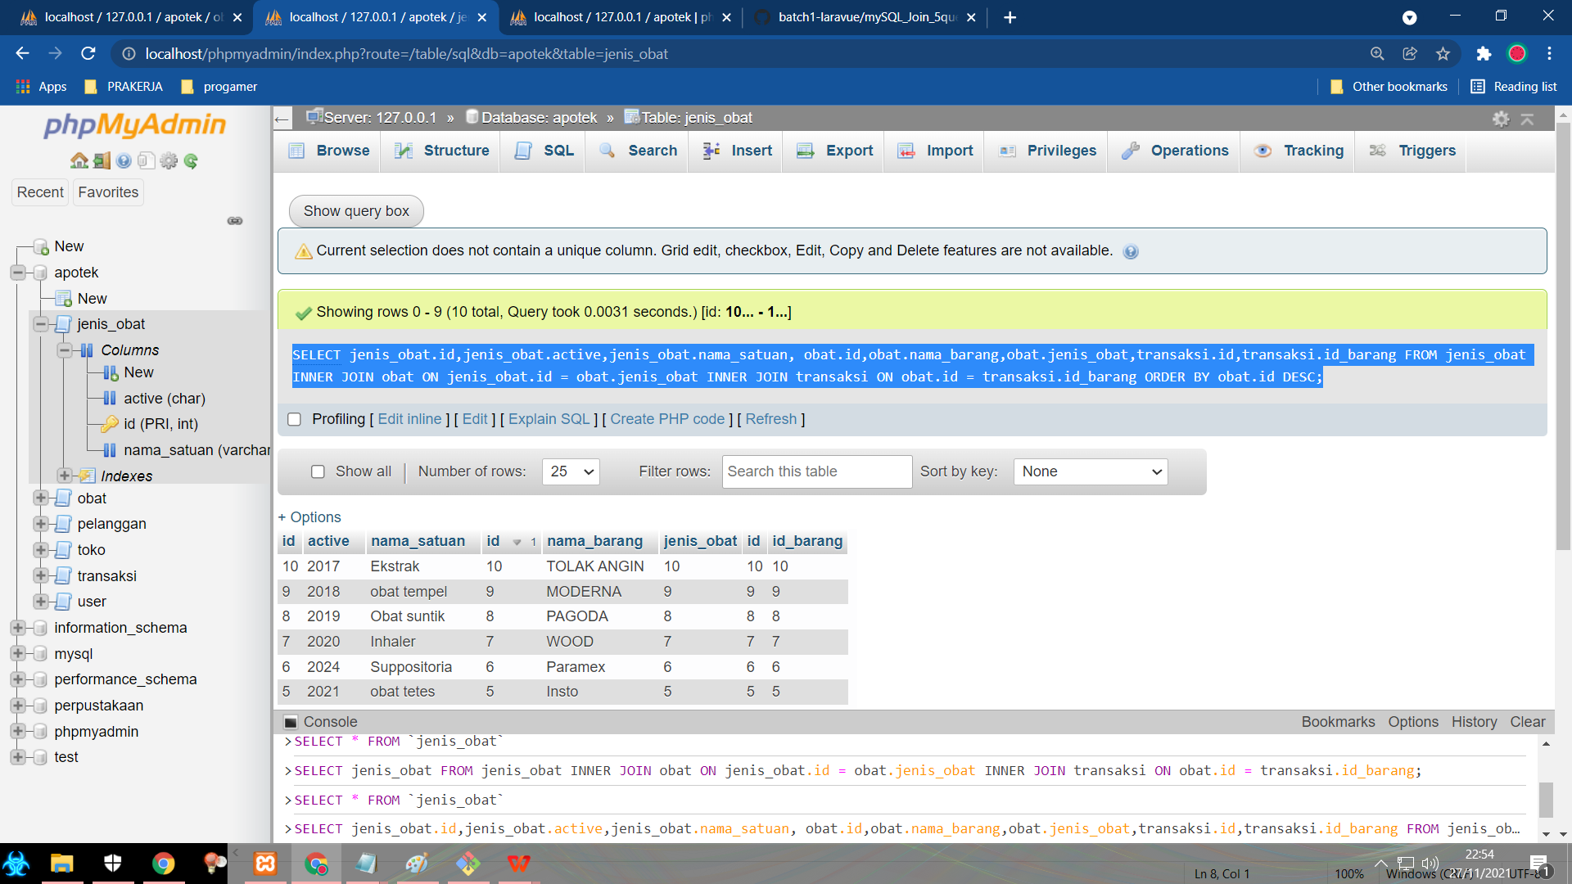

1. Syntax [SELECT](http://localhost/phpmyadmin/url.php?url=https://dev.mysql.com/doc/refman/8.0/en/select.html" \t "http://localhost/phpmyadmin/index.php?route=/table/mysql_doc) \* FROM [user](http://localhost/phpmyadmin/url.php?url=https://dev.mysql.com/doc/refman/8.0/en/information-functions.html" \l "function_user" \t "http://localhost/phpmyadmin/index.php?route=/table/mysql_doc) INNER JOIN transaksi ON [user](http://localhost/phpmyadmin/url.php?url=https://dev.mysql.com/doc/refman/8.0/en/information-functions.html" \l "function_user" \t "http://localhost/phpmyadmin/index.php?route=/table/mysql_doc).id = transaksi.id\_user INNER JOIN pelanggan ON transaksi.id\_pelanggan = pelanggan.id;

